Farmer

Online Market place

Buyer

Payment

Delivery staff

Admin

Order placed

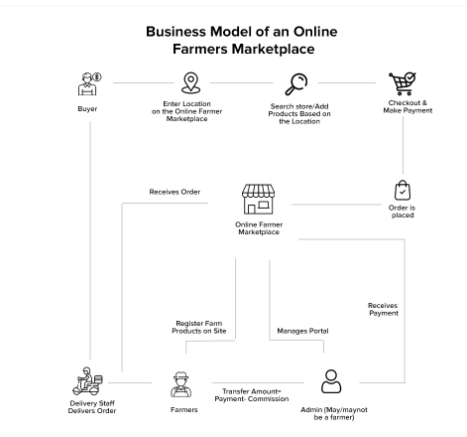

Farmers are left with very little as Middlemen Bridge the gap between farms and markets, earning margins at every point of the distribution chain.

Understanding this market vacuum, social enterprises are looking into how they may use the internet’s power and the growing availability of mobile phones to establish direct market connections between farmers and purchasers.

These businesses assist farmers in obtaining greater prices for their produce by eliminating middlemen from the distribution chain. They also help farmers save money by securing purchases and payments at the farm gate.

**What Can Farmers Sell Online?**

Below mentioned are some generally consumed food products that farmers can sell by developing an organic products ecommerce platform:

* Fruits and Vegetables
* Dairy Products
* Meat & Seafood
* Bakery Products
* Organic Food Products

## Business Model of an Online Farmers Marketplace

In this model business personnel form partnerships with farmers from various parts of the country who will set up shop on the market and sell their fresh produce. Farmers can use an internet agricultural e commerce platform to manage inventory, sales data, and product deliveries, among other things.

Buyers will create an account on the organic ecommerce platform, add food products to the cart, then make payment for their order. Buyers can simply order fresh, healthy, locally sourced products from the comfort of their homes using this method or they can also buy direct from farmers online. The merchandise will be delivered to the customer’s location by delivery personnel. Product shipment can be handled by either the operator or a third-party logistic provide.

## Components Of The Model

Many buyers are making use of technology to improve market linkages by utilizing technology to satisfy the increased demand for fresh farm produce from by consumers. It is better to create web-based and mobile-based platforms to sell fresh agricultural items to consumers directly.

### **Features for Sellers**

* **Vendors can sign up quickly and easily**

Simplify the onboarding process for your clients to save them time.

* **Product management that is effective**

Farmers should be able to quickly add or remove any items they possess, set prices, and supply other pertinent information

* **Order processing is simple and convenient**

Vendors need to know exactly how to buy organic products online store, what was ordered, how much it cost, and when it was delivered, as well as be notified of any changes in the delivery process.

* **Tools for communication**

To rapidly fix any issues, sellers and buyers must interact with one another.

* **System of evaluation or rating**

Buyers want to know that they can trust the seller at all times.

* **Rating and evaluation of system**

Buyers want to know that they can trust the seller at all times. Farmers can develop confidence with future customers by allowing comments from prior buyers.

* **Promotion of goods**

The buy and sell organic food ecommerce marketplace should include tools for farmers and suppliers to promote their products, such as featured products or discount promotions, so that they may sell more.